
Year 11 ATAR Chemistry
Task 10: Intermolecular Forces & Solubility Test
Weighting: 5% of Year Grade
NAME: ______________________________
TEACHER’S NAME: ___________________
Required Resources:
___ / 56
Blue or Black pen, Ruler, Calculator, Chemistry Data Book
Not Allowed:
Notes, Personal Periodic Tables
SECTION | NUMBER OF QUESTIONS | AVAILABLE MARKS | MARK
Multiple Choice | 10 | 10
Short Answer | 10 | 30
Calculations | 3 | 16

SECTION A: MULTIPLE CHOICE SECTION (10 marks)
INSTRUCTIONS
For each question, shade the box to indicate your answer. Use only a blue or black pen to shade the boxes. For example, is b is your answer:
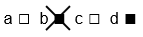
If you make a mistake, place a cross through the square and shade your new answer, for example d:

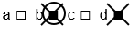
If you then want to use your first answer b, cross out d and circle b:

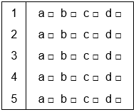
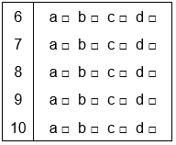

- Which of the following molecules would have the highest boiling point?
  - Phosphorus pentachloride (PCl₅)
  - Cyclohexane (C₆H₁₂)
  - Propan-1-ol (CH₃CH₂CH₂OH)
  - Hydrobromic acid (HBr)

- Which of the following statements is incorrect when describing carbon dioxide?
  - Carbon dioxide contains polar bonds
  - Carbon dioxide molecules are held together by dipole-dipole forces
  - Carbon dioxide is a non-polar molecule
  - The central atom in carbon dioxide has no lone pairs of electrons

- The bond angle between each of the four hydrogen atoms in methane is 109º. Why is this?
  - It is the only way that hydrogen atoms will fit around the carbon atom
  - The spacing of the hydrogen atoms makes it easier for them to form intermolecular forces with other atoms
  - The electron pairs around the carbon atom repel each other, maximising the distance between them
  - It maximises methane’s polarity

- A molecule with a shape that is trigonal pyramidal has:
  - 4 bonding pairs of electrons
  - 3 bonding pairs of electrons
  - 4 bonding pairs of electrons and one lone pair of electrons
  - 3 bonding pairs of electrons and one lone pair of electrons

- Which of the following statements is incorrect?
  - A substance can contain polar bonds but be non-polar overall
  - A substance that is geometrically symmetrical is always polar
  - Elemental molecules are always non-polar
  - A polar molecule can form attractions to ions

- Which of the following three molecules will have the lowest vapour pressure?

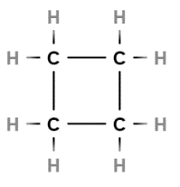
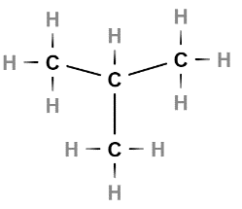
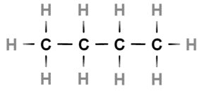

  - Butane
  - Methylpropane
  - Cyclobutane
  - They will all have the same vapour pressure
- Which of the following molecular shapes has three electron groups around the central atom?
  - Tetrahedral
  - Trigonal pyramidal
  - Trigonal planar
  - Both trigonal pyramidal and trigonal planar

- The two molecules shown below are similar in molecular structure in mass:

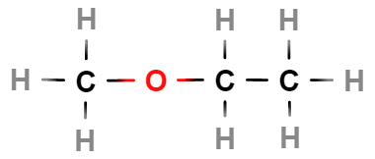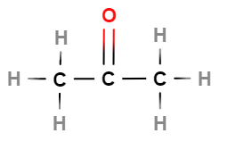
methoxyethane acetone

Each molecule contains three carbon atoms and one oxygen atom, however methoxyethane has a boiling point of 6.8ºC and acetone has a boiling point of 56ºC. What is a correct explanation of this?
- The oxygen atom in methoxyethane is not as accessible for hydrogen bonding
- Oxygen atoms that form single bonds do not hydrogen bond with other molecules
- Acetone is a shorter molecule which allows it to form more intermolecular forces
- The more hydrogen atoms a molecule has, the lower the boiling point

- The following two molecules will form which of the following intermolecular forces with each other?
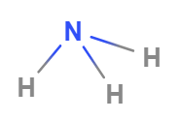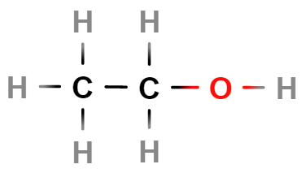
Ammonia Ethanol

- Dipole-dipole forces and hydrogen bonds
- Dispersion forces and hydrogen bonds
- Hydrogen bonds
- Dispersion forces, dipole-dipole forces and hydrogen bonds

- Increasing the temperature of a solution will cause the solubility of a gas to:
- Decrease
- Increase
- Remain constant
- Randomly fluctuate

SECTION B: SHORT ANSWER SECTION (30 marks)
- Draw Lewis structures for the following substances:
Sulfur dichloride (SCl₂) | Calcium nitride (Ca₃N₂)
Ammonium chloride (NH₄Cl) | Hydrogen cyanide (HCN)
(4 marks)
- Identify the following molecular shapes and provide one example of a molecule with that shape.
Name of shape | Diagram of molecule | Example of molecule
 | 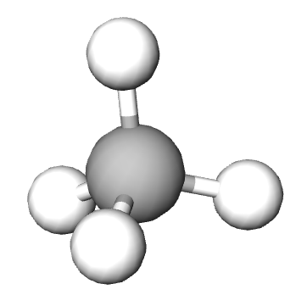
 | 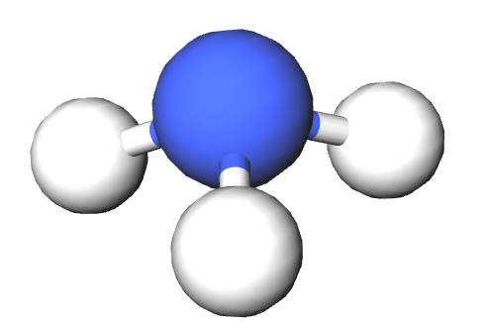
 | 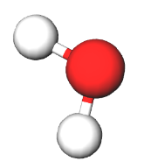
(6 marks)
- The following graph shows the boiling points of simple covalent compounds that include hydrogen. One line represents the trend in boiling point of the group 6 elements and the other represents the trend in boiling point of the group 7 elements.
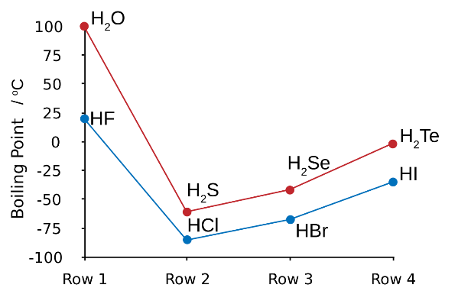

  - Explain why HF has a much higher boiling point than HCl, HBr and HI. (1 mark)

  - Explain the increase in boiling point from HCl to HI. (2 marks)

  - Draw two diagrams, one that shows the interaction of a potassium ion with a water molecule in solution and one that shows the interaction of a chloride ion with a water molecule in solution.
(4 marks)
- Propane is a gas which is used to power gas hotplates whilst pentane is a liquid component of gasoline. Using your knowledge of intermolecular forces, explain why these compounds exist in different states at room temperature. (2 marks)

- What is vapour pressure? Explain how this property relates to the strength of intermolecular forces. (3 marks)

- For the following reactants, produce a balanced chemical equation, including states of matter.
(6 marks)
Ammonium bromide reacting with silver nitrate.
Chromium (III) chloride reacting with sodium sulphate.

- Explain why glaciers weighing tonnes are able to float in liquid water. (2 marks)
SECTION B: CALCULATION SECTION (16 marks)
- A laboratory technician wanted to determine the amount of iron in a mineral sample by reacting it with a solution of dichromate ions (Cr₂O₇²⁻) according to the following chemical equation:

6Fe²⁺(aq) + Cr₂O₇²⁻(aq) + 14H⁺(aq) 6Fe³⁺(aq) + 2Cr³⁺(aq) + 7H₂O(l)

  - A solution of 0.05 molL⁻¹ potassium dichromate (K₂Cr₂O₇) was required for this test. Calculate the mass of potassium dichromate needed to prepare 250mL of solution. (3 marks)

A 4.3g sample of the mineral was ground and digested in acid to leach all of the iron into solution. Tin chloride (SnCl₂) was added to convert all of the iron in the leach solution to Fe²⁺ ions. It was found that 28.2mL of the potassium dichromate solution was needed to completely react with all of the Fe²⁺ ions.
  - Calculate the percentage of iron in the mineral sample. (5 marks)

- An analytical chemist wanted to perform a copper analysis by atomic absorption spectroscopy and needed to prepare a range of calibration standards to optimise the instrument. She began by preparing a working solution of copper sulfate (CuSO₄) with a concentration of 250ppm. She then diluted this solution to prepare standards with concentrations of 2, 5 and 10ppm.

Including calculations, explain how she could prepare 100mL of each standard from the working solution. (6 marks)

- A solution of magnesium carbonate has a concentration value of 163 parts per million (ppm). Express this value in moles per litre. (2 marks)

END OF TEST
Extra working space:

